JUNE 2013

INTRODUCTION & THANK YOU
I would like to start by thanking all the people who supported me during the recent County Council election. I can assure everybody that I will be working hard for all residents in the Woodstock Division to ensure that we have the best possible services. I would like to take this opportunity to thank all my opponents for the way the election campaign was conducted.

FORMING A STABLE ADMINISTRATION
There was no party with an overall majority at County Hall. Three independent members formed an alliance with the Conservative Group to allow a stable administration to be established. I was elected as Leader of the Council and announced the Cabinet at the Council Meeting on 14th May.

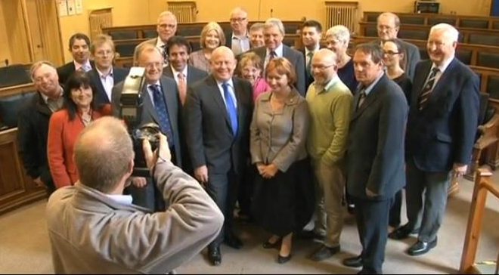
Around two-thirds of the Conservative-Independent Alliance, Picture from BBC News

OPERATION BULLFINCH
The conviction of seven men following Operation Bullfinch has raised numerous questions at County Hall and other agencies. We are desperately sorry that the abuse was not stopped earlier, however, lessons have been learned and we have implemented measures to stop a repeat of these criminal activities. Unfortunately this type of crime is committed across the nation; we need a national debate to prevent it happening anywhere across the country in the future. There will be an Independent Serious Case Review led by David Spicer QC who specialises in child protection law. This will be open and transparent and the Leader of the Council intends to implement all the recommendations.

BROADBAND CONTRACT
The Council and the Government are investing nearly £14 million to improve Oxfordshire’s broadband network and infrastructure. On 21st May, the Cabinet agreed to award the contract subject to some delegated amendments. This is expected to provide superfast broadband (24Mbps) to 90% of Oxfordshire by 2015.

LOCAL TRANSPORT PLAN 3 CONSULTATION
As part of the third Local Transport Plan (LTP3) which runs from 2011 to 2030 there is an annual review, you are invited to take part in the web-based consultation from July until September.

ADULT SERVICES
Following public consultation from November to February 2013, Cabinet is meeting in June to consider the Older People’s Strategy. This plan encourages people to stay healthy as they age and support older people who need help and care. It has been put together by the NHS, County and District Councils, organisations that work with older people and older people themselves. The Cabinet will also consider final approval for the new pooled budget arrangements with Oxfordshire Clinical Commissioning Group (OCCG) and in July will assess care home fees following the consultation.

FUNDING OPPORTUNITIES
There are a number of funds available to local organisations in the Division.
- Councillors Community Budgets
We have continued to fund these popular local funds to support local organisations. If you know of any organisations that might be interested, please contact me or seek further information at http://www.oxfordshire.gov.uk/cms/content/councillor-community-budgets
- Area Stewardship Funding
These are continuing but are now organised differently. I will attend meetings with other councillors in my locality to pool our funds together for greater effect where possible. It is used to fund highway maintenance issues in particular.
- Chillout Fund
We have continued a £100,000 fund to support projects for children and young people across the County. More information is available at http://www.oxfordshire.gov.uk/cms/content/chill-out-fund-youth-activities-and-projects

Ian Hudspeth
07956 270 318

