REPORT TO PARISH COUNCILS MARCH 2014

THE BUDGET
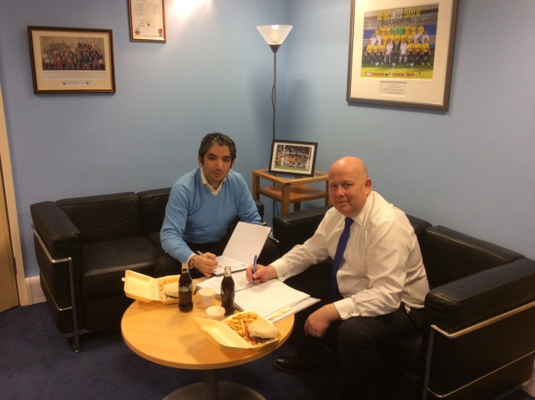
The budget was decided at the Full Council meeting on 18 February. An increase of 1.99% was agreed and whilst any increase should be avoided, this small increase of 46p per week for a band D property means that some valued services can be retained.
Finalising the budget with Cllr Arash Fatemian, Cabinet Member for Finance

There were some difficult decisions to take, however money was reinvested into the priority areas as opposed to reducing spending and the Council’s overall new savings figure remains at £64m, with £31m of savings having already been planned. The Council is on track to have made £170m of savings from 2010 to 2014. The total of £265 million of savings over the period of 2010 to 2018 has been achieved by sharing services with other councils
and reducing costs, such as the number of directors, by 50%.

Despite all the savings and reductions there were some positive announcements:

- An additional investment of £800,000 to end 15 minute personal care visits by extending the time of visits;
- An extra £350,000 will be available for the setting up of a Multi-Agency Safeguarding Hub in Oxfordshire;
- There will be £1m extra for general highway maintenance to be spent across the county – with priorities for this spend to be determined during coming months;
- A total of £400,000 will be set aside as a contingency to deal with issues stemming from flooding and other winter weather issues – the exact nature of how this money will be spent will be determined once full assessments have been made when waters have subsided;
- A total of £315,000 will be invested in community budgets.

The budget proposals were fully supported by the Conservative-led Alliance whilst opposition members voted against the proposals, including those listed above.

It has been a challenging budget and now we have to make sure we deliver the savings.

FLOODING
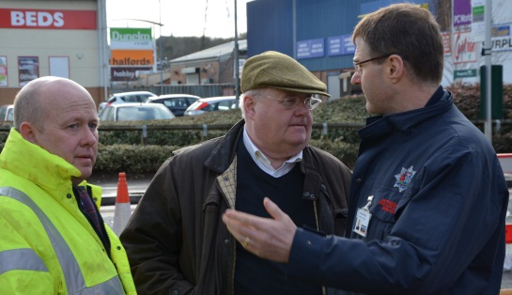
The rain still continued to fall during February, adding to the existing high river levels and water table. The County Council’s Fire & Rescue service worked 24/7 alongside the Highways team to deal with incidents as they occurred; to try to keep residents safe and Oxfordshire moving during the month. There was some innovative work on the Botley Road that meant it remained open during the bad weather as opposed to having to be closed the previous month.
Chief Fire Officer Dave Etheridge explaining the issues to Secretary of State Eric Pickles and myself.

The Deputy Leader of Oxfordshire County Council Cllr Rodney Rose will be hosting a flood summit in March to bring all the various agencies and partners together to find a solution to the flooding that appears to be becoming a regular occurrence. If you have any ideas, then please do not hesitate to contact me so that I can feed them into the debate.

HOUSING
The County Council is not responsible for the planning of houses and developments that is down to the City and District Councils. However, we do have a major part to play as we are responsible for key infrastructure such as education and roads. Currently there is a Strategic Housing Market Assessment taking place across the county to determine what growth will happen over the next 20 years. This will then feed into the Local Development Frameworks of the City and District Councils as to where the final allocated sites will be. Already the Vale of White Horse DC has announced a substantial increase in their housing numbers. The County Council will be assisting in this process to ensure that they are in sustainable locations with the required infrastructure.

RAIL TRAVEL
The Office of Rail Regulation has issued the latest station usage figures which show 529,272 extra rail journeys in Oxfordshire in 2012/13 compared to 2011/12.
A total of 16.3 million journeys were recorded at the 22 stations, compared to 15.8 million in the previous year. The station with the one of the biggest annual increases is Hanborough (up 26.5%) to 172,994 users.

BROADBAND
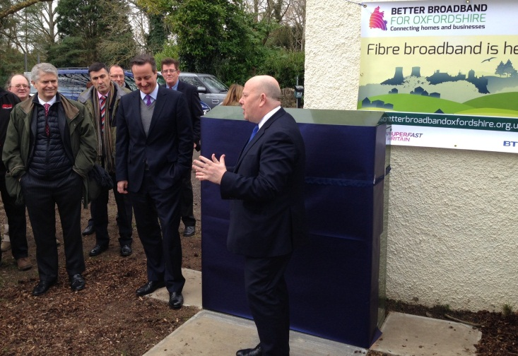
The roll-out of Better Broadband across Oxfordshire has started and I was delighted to attend the recent launch at Alvescott with the Prime Minister. The full programme will be delivered by 2015; the details of when Better Broadband arrives locally can to be found on the Council’s website at:

https://www.oxfordshire.gov.uk/cms/public-site/broadband-oxfordshire

Ian Hudspeth
07956 270 318
Ian.hudspeth@oxfordshire.gov.uk

