Apologies for a delayed Parish report I had hoped to be reporting on a fantastic victory at Wembley for Oxford United. Despite a good performance the team lost however it was a fantastic day out for everybody and I have to congratulate Chiltern Railways on an excellent service from Oxford Parkway. Now we can concentrate on gaining promotion.

PROPOSALS FOR UNITARY COUNCIL

Even before the announcement from the Districts for 4 unitary councils across Oxfordshire, I have been clear since 16th February that all the Leaders should sit down together without any preconditions to find the best way forward for the residents of Oxfordshire. Unfortunately once again the Districts have started a process without involving the County to commission a report into the options available. The County only found out about the tender process after it had started. In that tender document it was made clear that the Districts were only considering 2 options. They have altered the document however it is still clear about their preferred option. The document is not publicly available and with the tender process due to finish in a few days by 8th April it’s completely flawed.

I have asked that an independently led report is commissioned that all parties can agree to look at all options in an open and transparent manner. If they do not agree to wasting taxpayers money on flawed report then the County will have to commission a report to ensure that the residents have full details. We have published our draft tender document online to ensure that stakeholders can comment prior to starting the process. I urge the other Leaders to join in a truly independent report as there is nothing to hide. Full details of our report can be found by following the link: http://ow.ly/10lAnJ.

DRAGON IGNITES BATTLE AGAINST POTHOLES

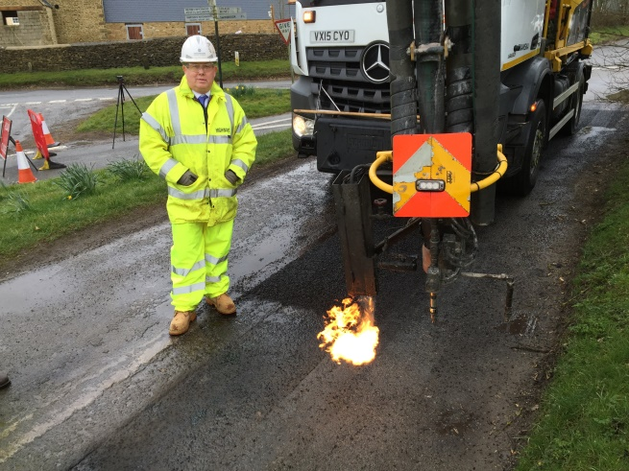
A new weapon is being deployed in the battle against potholes on Oxfordshire’s roads. The ‘Dragon’ – so called because of the fire breathing nozzle it uses to dry out potholes – is a mobile patching machine that has already fixed many hundreds of potholes and a multitude of other defects on the county’s roads. Skanska, OCC's highways maintenance contractor, has added the Dragon to its arsenal against potholes and is using it to good effect across Oxfordshire, Cambridge and Peterborough. The machine repairs an average of 20 defects day and has filled up to 44 potholes in one shift. So far it has fixed just short of 2,000 in Oxfordshire. The traditional method of pothole repair consists of a two-person gang and a lorry manually filling the potholes with hot tarmac. In the right circumstances, potholes filled using the Dragon can cost as little as £10 compared to £70 for traditional methods. It is also safer and provides a more environmentally sustainable solution. The potential savings that Dragon brings allows additional focus on repairing many of the defects that have yet to form into potholes. These repairs can be done at the same time due the multi-function repair capabilities of the Dragon. It can fill pot-holes, seal cracks and provide a thin overlay to minor surface damage. This preventative maintenance saves money in the long-term as the repairs are all undertaken at the same time.

WOODSTOCK LIBRARY

The Library will be closed from close of business on Saturday April 16th, reopening on Monday April 25th. We have the opportunity to recycle some surplus shelving and furniture as a result of the opening of the new Bicester Library. Much of this reusable equipment is newer than the existing fittings we have at Woodstock so the library is going to benefit from a small-scale face-lift. The closure is necessary to enable the necessary works to take place.

OXFORD CITY CENTRE’S NEW TEMPORARY LIBRARY NOW OPEN

The central library closed February 27 as part of ongoing redevelopment work.
A new, smaller, temporary library has now opened in Oxford’s Castle Quarter with facilities including books, audio books and DVD’s for adults and children. Due to the size and facilities available at the site of the temporary library, Internet access, reference information, newspapers, journals and music services will not be available. However these services will still be provided at other libraries in the area. The library service’s Reference Online service and eBooks and eAudio lending services will also be available. Redevelopment of the whole Westgate building is the reason for the relocation – with the central library set to reopen back in its original building in October 2017. The existing front of the current Central Library building will be replaced to become part of the new curving wall forming the south side of Bonn Square marking the entrance to the new Westgate Oxford.

RECYCLING CENTRES TO OPEN LATE ON THURSDAYS

Opening hours on Thursdays at OCC's Household Waste Recycling Centres will be extended from 7 April to 29 September. The sites will be open until 8pm on Thursdays in addition to the normal hours of 8am-5pm every day (including Sundays). The Household Waste Recycling Centres can accept a wide range of materials for recycling including garden waste, textiles and electrical items. Food waste should always be placed in the food caddies provided by the district council and collected as part of the kerbside collection scheme. More information about the sites, including layout and a full guide to what can be recycled can be found at https://www.oxfordshire.gov.uk

STREET LIGHTING

OCC's current Street lighting contract with Scottish & Southern Electrical (SSE) was until March 2024, however, the contract contained a single break point at 1st April 2016. In July 2015, SSE served notice on OCC that they intended to activate this break clause as the contract was not affordable to them for its full duration. Negotiations to achieve a compromise were unsuccessful. OCC therefore has to implement interim arrangements while a new maintenance contract is procured. The interim contract is expected to last 18 months. For the first 6 months there will be an emergency/make-safe service only. Beyond that period OCC will look to increase the level of service provided to more than just emergency/make-safety activity as appropriate.

The street lamp LED replacement project is a one-off capital programme of works funded through DfTs challenge funding. A separate procurement arrangement is being made for this project to ensure its continued delivery as planned.

It is appreciated that there will be concerns locally about the impact of this interim arrangement and reduced level of service, but in a time of significant financial pressures, the termination of the current street lighting contract provides an opportunity to procure a new and improved street lighting contract. The county council will also be able to take advantage of recent improvements in technology and general advancements within the sector.

KEEPING HGVS MOVING WHILE REDUCING THE IMPACT ON COMMUNITIES

A free online mapping tool has been launched to help freight and logistics companies plan their routes through the county. Oxfordshire Freight Gateway is linked to the National Freight Journey Planner and is designed to help logistics managers and drivers of large goods vehicles to select the most appropriate routes for their journeys in Oxfordshire. A suitable route is provided based on the vehicle’s weight and dimensions and journey details. Details here: http://freightgateway.co.uk/oxfordshire/

TRIP TO CALAIS

I visited Calais in a personal capacity so that I could form my own opinion of the situation, speaking direct to the volunteers and those in the camp. I have to admit that expectations of what I would see were complete different to the reality of the camp. The southern half had been cleared by the authorities leaving a bleak and barren landscape with smouldering fires as part of the background.

As we walked through the remaining section of the camp the atmospheres was tense as obviously some people wondered why we were there and did not want to be photographed.

We did have some interesting conversations with men from Afghanistan, Ethiopia, Iraq and Pakistan who expressed a desire to come to the United Kingdom to work. Obviously I cannot substantiate the claims but within the camp there were shops and building of new ‘shacks’.

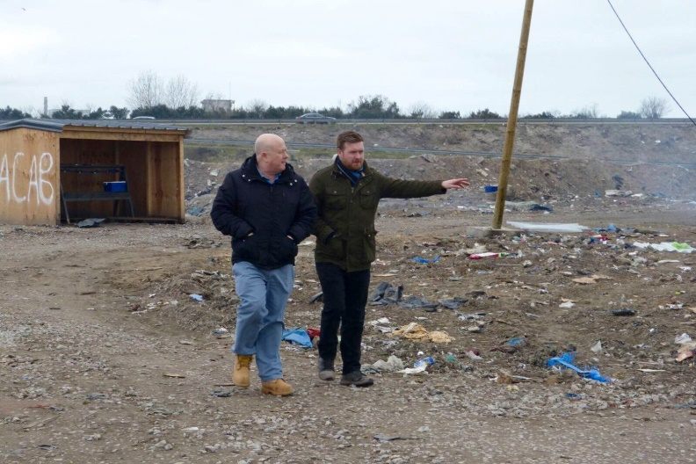
There were children running around seemingly enjoying themselves unaware of the awful conditions they were living in.
Walking through the camp with Liam Walker

I’m not sure what the answer is but we cannot ignore the situation that is only 4 hours from our comfortable lifestyle. We have to work in their own countries to make sure that they do not have to make the terrible journey across Europe to end up in such a terrible place. If people are prepared to make such a journey we have to consider how bad the conditions are in their own country.

There are a number of charity groups within Oxfordshire who are working to help the situation please contact them for more information.

Cllr Ian Hudspeth
07956270 318
Ian.hudspeth@oxfordshire.gov.uk

