OUR LIBRARY

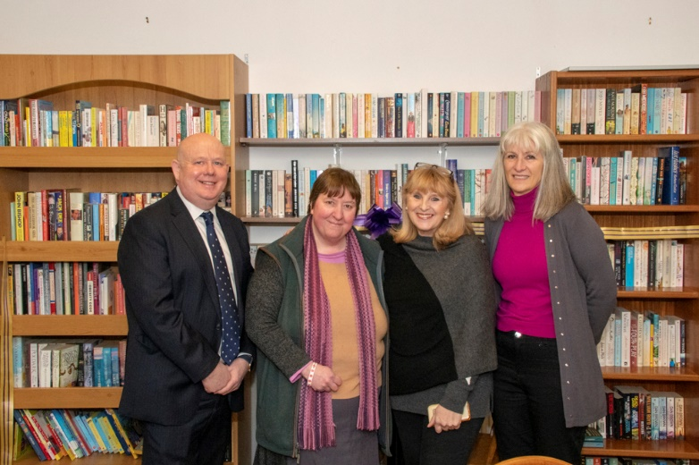
Pictured above at the opening with Diane Vale of the shop, Parish Chairman Kate Carter-Windle and Alison Umney

Congratulations to Alison and John Umney along with Parish Chairman Kate who have worked hard to open a community library in Middle Barton Stores. Residents will be able to borrow books or sit in comfortable chairs having a cup of tea or coffee whilst browsing books. I was delighted to be at the opening of this new community facility.

BUDGET

1. COMMUNITIES TO BE OFFERED HELP WITH YOUTH SERVICES

Young people and their families in Oxfordshire are now set to benefit from improved community-run youth services if county councillors agree grant funding when they set the council’s budget next week. Youth groups will be invited to bid in to a £1m fund over two years, with encouragement to find match-funding from their local communities. Feedback from residents points to strong support for improving community-run youth services, and this money would help existing projects expand and new ones get off the ground. By offering start-up funding, the council has already helped many community-run groups provide support for young children and families, and it is hoped the same could happen for youth services. Community-run youth services would complement the work of the county council’s Children’s Services department, which targets its resources at children at risk of abuse and neglect. This proposal has been made possible by better than expected Council Tax collection following growth in Oxfordshire.

2. COUNTY COUNCIL TO INVEST IN SCHOOLS, TRANSPORT AND STREETLIGHTING

Residents of Oxfordshire will see highway improvements, new school buildings and energy-efficient streetlighting thanks to a £1 billion investment over the next ten years as part of the county council’s budget. However, the county council is also warning that funding pressure on services remains as demand for social care for vulnerable children and adults continues grow and continued financial prudence is required to meet those demands.

Transport schemes across the county are set for funding approval so the county council can improve journeys for drivers, pedestrians, cyclists and public transport users. Nearly £20m will be invested to increase the provision of school places for children with special needs in the county, including rebuilding Northfield School in Oxford with more pupil places.

Capital funding is for large one-off projects such as highway repairs or building work to assist the council meet its obligations, such as creating extra school places - as opposed to the normal revenue budget which covers funding for the costs of day-to-day services. Most of the funding for capital programme is made up of government funding and developer contributions, which cannot be used for any other purpose.

The proposed capital programme includes government funding through the Oxfordshire Growth Deal, agreed by all Oxfordshire councils. Elsewhere in the Capital Programme a £41m street lighting improvement programme continues to be part of the investment plan, with traditional lanterns to be replaced with more energy efficient LED lighting, saving money in the long-run. The ten-year capital programme is part of the council’s proposed budget for next year, which has been put forward following public consultation. The proposals will be put before all councillors on 12 February 2019.

Pressure on funding for day-to-day council services continues as the council increases funding for to support of Oxfordshire’s most vulnerable children and adults. There is also uncertainty about future government funding, which is making budget planning harder.

To make sure the growing number of children at risk of abuse and neglect are protected, the children’s social care budget has increased annually. It was £46m in 2011 and is forecast to be £95m in 2022/23 – more than doubling in ten years.The council’s budget for adult social care could increase by £5m in 2019/20, with further annual increases reaching nearly £6m by 2022/23 to increase support for the growing number of older and disabled people.

Meanwhile planned redesign of the council around the changing needs of residents and communities will maintain or improve services, with investment in digital technology enabling us to save money in the process.

OCC is now reviewing the digital technology needed to make the council run more effectively and efficiently, including improving customer service by making it easier to access services online. The council has identified savings of £50m from changing the way services are delivered and has already started implementing these changes, including improving online ‘self-service’ HR and finance systems used by staff. As part of the partnership with Cherwell District Council, legal services for the two councils are being joined up.

I’m pleased that in Oxfordshire County Council’s budget there is funding for Mirco Asphalt treatment for the B4030 from Hopcroft Halt to Barton Lodge, the work will be carried out in the summer. This is a surface treatment is a preventative maintenance treatment, used to seal the existing road surface, improve the texture and helps water evaporate. This will improve the surface traction and all the lines will be repainted. The bollards will repaired or replaced along with a review of the signage to warn drivers of the hazards. This is welcome news as there has been local concern with vehicles leaving the road.

WINTER
This winter has been mild but over the last week the team has been working hard. We have a 26-strong team who are on standby throughout the winter to turn out at all hours. In Oxfordshire the county council grits all A-roads, B-roads and some C-roads. This amounts to 1,200 miles per gritting run which is the equivalent of travelling from London to Iceland, which takes about 3 hours. To work effectively the salt needs traffic to make it work, driving over it mixes it with any ice on the road surface but salt only works down to about -6°c; care is always needed if you are driving in freezing temperatures even if you can see a road has been salted. I would like to say a big thank you to all members of the team who work throughout the night so the roads are as clear as possible in the morning.

MORE THAN 40,000 ROAD DEFECTS REPAIRED IN OXFORDSHIRE SINCE LAST WINTER
OCC’s highways teams are out daily relentlessly resurfacing roads and pavements. They have been able to more work than last year thanks to the county council putting in extra cash over and above the normal budget in response to the problems caused during the last cold spell. Since January 2018 the council has repaired 40,117 defects. That’s an average of 3,652 repairs a month which is quite colossal compared to what was needed during the same time period the year before – a total of 34,677 defects were repaired between Jan-Dec 2017. Due to severe weather last winter, pothole fixing peaked between February and May with nearly 18,000 being repaired. The county council this year invested an extra £10m in road repairs which has resulted in extra major resurfacing projects being completed as well as smaller, but no less important, repairs being completed across Oxfordshire.

OXFORDSHIRE HEALTH AND WELLBEING STRATEGY SURVEY IS LAUNCHED
People living, working and studying in Oxfordshire are being encouraged to help set the future direction of the county's health and wellbeing strategy. A draft strategy has been developed by Oxfordshire's Health and Wellbeing Board – the partnership between local NHS services, local councils and Healthwatch Oxfordshire. The board's joint working approach aims to improve everyone’s health and wellbeing, but especially of those people who have health problems or are in difficult circumstances due to age or vulnerability. The strategy outlines the actions the board is proposing to take, but it now wants further input from the wider public. Feedback from previous public engagement, especially around the health and wellbeing of children and young people and older people was used in developing the document. The survey document and draft strategy is available at: https://consult.oxfordshireccg.nhs.uk/consult.ti/HealthWellbeing/consultationHome

CASH BOOST FOR FUTURE OF TRANSPORT IN OXFORDSHIRE
Oxfordshire’s road users could see a technological revolution take place in the coming years that could involve important traffic information being used to help them to get around more easily thanks to a successful bid for £1.25m of Government funding. The cash, which has been through the national GovTech Catalyst initiative towards work to transform the existing Oxfordshire traffic management system – ready for the Government’s hoped-for introduction of connected vehicles by 2021 as well as other new mobility options, such as electric vehicles. Many people think of the new wave of transport in terms of cars. However, connected vehicles – anything that can be linked up via the internet to a wider system – could mean vans, buses, lorries, motor or pedal cycles. Even wheelchairs could take advantage of new technology to get around more easily. Everyone stands to benefit. Oxfordshire’s money will pay for researching how data – of which there is lots and from varied sources – could be used to help manage traffic in the future.

WATCHDOG SAYS OXON HEALTH AND SOCIAL CARE SERVICES MORE JOINED UP
Significant work has been done to join up services across Oxfordshire that is already demonstrating improved outcomes for people, according to a follow-up review by the national regulator for health and social care published on Wednesday, January 9. The Care Quality Commission (CQC) found key improvements had been made eight months into an 18-month action plan that was agreed by Oxfordshire health and social care organisations after an initial review by the CQC in November 2017. Following the first review, a key priority for system leaders has been to work more closely together to plan and deliver health and social care services, particularly for older people.

Cllr Ian Hudspeth
07956270 318
Ian.hudspeth@oxfordshire.gov.uk

