Integrated Care System

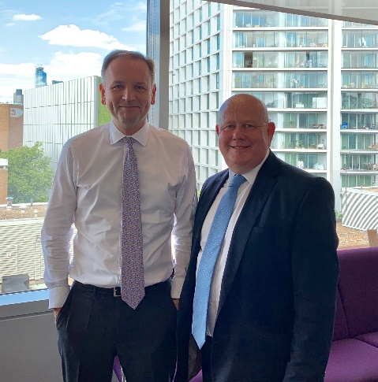
Oxfordshire is to be part of a new ‘integrated care system’ created by the NHS in England to improve health and social care services. The new joined up care system also covers Buckinghamshire and Berkshire West. The NHS and local authorities in the three areas aim to deliver a person-centred vision for health and care services, making sure services are planned and delivered as locally as possible. Health and care organisations will work collectively to bring better health outcomes for people and ensure effort is not duplicated or resources wasted.

I recently met with Simon Stevens, Chief Executive of the NHS to discuss what it means for Oxfordshire and in particular our residents. I see this as a positive move to integrated care across the country which gives us the opportunity to really make a different for our residents and communities. Locally, I’m convinced that working together in partnership with the NHS we will deliver huge benefits to the health and care system which will improve the health and wellbeing of Oxfordshire’s residents.

Tackley School Library

I went along to visit the new library facility at Tackley Primary school. This is a good example of all working together to provide a bright space to encourage children to read more books, well done to everybody who worked hard on this project.

I’m pleased to be able to confirm that the permanent public Wi-Fi solution is now fully operational at Woodstock Library. The Library staff have been instructed on how to connect to the Wi-Fi to enable them to offer assistance to members of the public when required.

The temporary solution that we put in place had been disabled, but remains present if ever needed in the future.

Parking

I had a very useful meeting with the new Cabinet Member, Norman MacRae, at WODC, along with some members of the Heart Of Woodstock group. We looked at all the areas around the town that could benefit from different parking solutions. I have been clear that the best solution for the town centre will be to have a residents permit scheme however these are not simple to implement particularly with the displacement parking caused in areas just outside a zone. There will be a parking survey by WODC, I urge all residents, not just those in the town centre to complete the survey to ensure we get the best data possible.

Its not just in Woodstock where there are parking problems other villages such as Bladon suffer too particularly inconsiderate parking that blocks driveways. I had a site visit to see what can be done to improve the situation.

Pilot project could restrict traffic outside Oxfordshire schools in a bid to reduce air pollution

Oxfordshire County council is considering the possibility of launching a ‘School Streets’ pilot project. The project aims to reclaim roads outside schools from traffic at the start and end of each day, reducing air pollution outside the school gates and making it easier for children to walk, cycle or scoot to school.
Two years ago, the east London borough of Hackney developed a blueprint for restricting traffic outside schools at opening and closing times. Seven schools are participating and since the launch of ‘School Streets’, the proportion of children cycling to school has increased by more than 50 per cent, with traffic outside the school gates reducing by around two-thirds.
‘School Streets’ projects have also been a success in Solihull and Edinburgh, with traffic flows reduced and plans in place to expand the schemes.

Following a successful Oxfordshire Schools Clean Air Network seminar at County Hall on Clean Air Day, six Oxfordshire schools have already expressed interest in joining the pilot.

Highway Repairs

Repairs and improvements on Oxfordshire’s roads continue with more than 34,000 potholes repaired over the last year, a 45 per cent increase on the previous year - and there’s more major repairs to come over the summer.

We recently announced an extra £13m for road maintenance for this financial year on top of its existing £18.5m programme of work – this follows last year’s additional £12m boost. The strategy is paying off with 34,159 potholes repaired compared to 23,486 the year before.
This year’s additional money will be spent across Oxfordshire’s towns and villages on resurfacing, drainage, bridge repairs and footways.

Last year’s extra cash saw more than 37 extra miles of road being resurfaced through a range of methods which also included surface dressing and micro-asphalting – both of which make road surfaces waterproof and extend their life.

I’m continually contacting the Highways team to ensure that the funds are used on some local schemes.

Network Rail

I had a meeting with all the directors of Network Rail discussing all the rail improvements required in Oxfordshire to enable people to move around. Obviously, I was parochial asking for more investment on the North Cotswold line to improve the service. I also discussed the Cowley branch line as its 5 years ago that we proved it was possible to run a passenger service yet there has been no more progress. It would make a massive difference if we could progress both of these projects which could have a shuttle service from Hanborough through Oxford to the Science park area. I will keep working to deliver both of these important projects.

Cllr Ian Hudspeth
07956270 318
Ian.hudspeth@oxfordshire.gov.uk

