**POLICE MOVE INTO THE FIRE STATION**

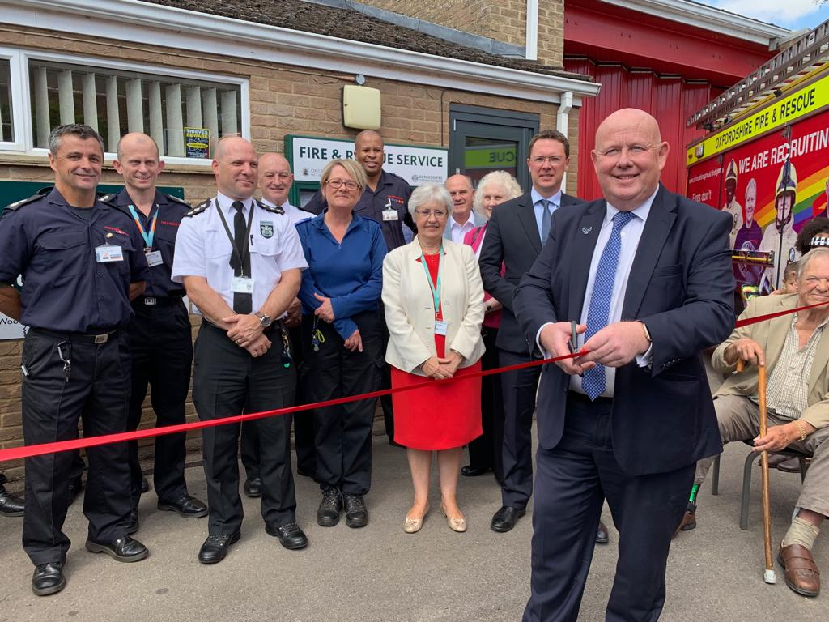

Woodstock’s neighbourhood policing team has relocated to their new base at Woodstock Fire Station, where they will share premises with colleagues from Oxfordshire County Council Fire and Rescue Service.

New Chief Fire Officer for Oxfordshire County Council Fire and Rescue Service, Rob MacDougall, said: “We are committed to thriving communities; working in partnership with other emergency services and support groups to achieve this. Co-locating teams at Woodstock makes absolute sense for our communities. Being in the same building will provide more opportunities for our teams to problem solve and identify news ways to deliver our prevention initiatives in a collaborative way, whether that is reducing the vulnerability to fire, crime, or other community safety issues.”

West Oxfordshire Neighbourhood Inspector, Steve Hookham, said: “This is the second co-location with Oxfordshire County Council’s Fire and Rescue Service, following the one in Chipping Norton, and we look forward to taking this opportunity to work more closely with them and build on our existing partnership working. The relocation of the neighbourhood policing teams to this new facility ensures that Woodstock and the surrounding communities will continue to benefit from a locally based police presence for the foreseeable future.”

**WOODSTOCK LIBRARY**

As you are aware from previous conversations on the matter, there have been structural issues with the walls of the former Woodstock Library which were uncovered during routine maintenance and health and safety inspections last year by Oxfordshire County Council operations team. Further extensive surveys revealed that the building on Hensington Road was damaged beyond economic repair and since then the County Council has been preparing the site for demolition.

We would like to inform you that work is about to start on demolishing the Woodstock Library very shortly. The current plan is that works are due to start during the week beginning 16th September 2019, however the start date could be brought forward on the advice of surveyors who are monitoring the condition of the structure.

All the relevant protective measures will be established around the site to ensure public safety. The county council has carefully planned the project to minimise the impact on people living and working in Woodstock but acknowledges there will inevitably be some disturbance from noise, dust and site vehicles in the area.

The county council remains committed to finding a permanent home for the provision of a library for the residents of Woodstock and continues to explore all options. In the meantime, a full library service will continue to be temporarily provided in The Oxfordshire Museum. This includes books, public access internet, activities (stay, play and learn), Wi-Fi, printing and photocopying.

**ST JAMES LUNCH CLUB**

I joined some of Stonesfield residents at the St James lunch which not only provides an excellent lunch but has speakers and games to help keep them occupied during their visit. This is organised by volunteers however funds are needed so I was delighted to be able to use some of my Priority Fund on this good project.

I have used the Priority fund across the division these are some of the projects I have helped. the Our Bus community bus, Tackley school library, Middle Barton CCTV, Woodstock WW1 commemoration. there is still funding available please contact me if you have a project in mind.

**ELECTRIC BLANKETS**

I hope we’ll continue to have some good weather, but winter will soon be upon us and now is the time to start planning ahead. Free electric blanket testing is offered over a two-week period during October at different locations around the county.

Book your electric blanket in for a free check

* Thame - Monday 7 October 2019
* Oxford - Tuesday 8 October 2019
* Banbury - Wednesday 9 October 2019
* Witney - Thursday 10 October 2019
* Abingdon - Friday 11 October 2019
* Oxford - Monday 21 October 2019
* Bicester -Tuesday 22 October 2019
* Henley - Wednesday 23 October 2019
* Chipping Norton - Thursday 24 October 2019
* Grove - Friday 25 October 2019

To pre-book an electric blanket safety check, phone 01865 895999 or email [communityengagement@oxfordshire.gov.uk](mailto:communityengagement@oxfordshire.gov.uk).

**GROWTH DEAL FUNDING**

The decision by the new Liberal/Green coalition at South Oxfordshire District Council (SODC) to defer endorsing the emerging Local Plan has serious implications for the Housing Infrastructure Fund (HIF) bid which would provide £218 million of vital infrastructure for the Didcot area.

The preferred options of the coalition at the council meeting on 18th July were to either revise or withdraw the emerging Local Plan however the decision was deferred. Should either of these options be taken then the probable outcome is the collapse of the HIF bid with the consequent severe impact on the Didcot area infrastructure. This would then probably mean South’s existing Local Plan would come under pressure and large-scale speculative planning applications might come forward on inappropriate sites. Neighbourhood Plans that many town and parish councils have spent time working on will continue to provide some protection, but there is a real danger that developers might seek to exploit the situation as there would be no new Local Plan for Neighbourhood Plans to align with.

Problems are not confined to SODC; if there is no HIF then the Vale Local Plan could also fail.

This could mean that within months of new administrations in South & Vale taking office, both Local Plans might fail due to the loss of £218 million for vital infrastructure in Didcot. A further consequence could then be the failure of the £215 million Growth Deal which contains £60 million for much needed affordable homes.

Meetings in September have been cancelled which means the crucial meeting is Full Council at SODC on 10th October.

I am continuing to working with members and officers at SODC to find a solution.

**Cllr Ian Hudspeth**

07956270 318

[**Ian.hudspeth@oxfordshire.gov.uk**](mailto:Ian.hudspeth@oxfordshire.gov.uk)