Thank you to everybody who is helping during these challenging times its greatly appreciated. Oxfordshire County Council is working with partners such as West Oxfordshire District Council and the NHS to help residents particularly the vulnerable, but the help of local voluntary groups is proving to be invaluable to ensure nobody is missed.

The Council sets its budget 9th February with £400,000 extra funding for drainage/vegetation clearance and 20 mph speed limits in villages that want them. The recent heavy rainfall has highlighted some areas that require additional work to keep the drains clear, I’ll be making sure that those areas get more frequent clearing. It’s important to coordinate the work with WODC to ensure the kerbs are clear overwise the rain simply pushes the debris into the drains. The additional funding for 20 mph speed limits will be to work with parish councils that see a lower limit as part of the solution to bring down vehicle speeds.

Other key points of the budget:
- A total of £1m long-term funding would be invested in expanding the youth offer in Oxfordshire. A study is due to report in the Spring on the needs of young people and how the wider partnership of the voluntary, community and public services can best provide support. An additional £500,000 of one-off accelerator funding will also be provided to develop sustainable long terms approaches and help tackle the impacts of the pandemic on young people.
- An extra £4m will be added to the adult social care budget for 2021/22. This includes a total of £1.35m for managing risks such as provider sustainability.
- The Better Care Fund (BCF) is a programme spanning both the NHS and local government. It seeks to join up health and care services so that people can manage their own health and wellbeing and live independently in their communities for as long as possible. For 2020/21, the county council agreed with health partners that £1.2m of the improved BCF for Oxfordshire would be used to support activities agreed to deliver better outcomes over the winter period in the county. However, it was one-off funding. The council is proposing to continue the funding for 2021/22, which would be used to support measures to help people be discharged from hospital and enable new ways of working and better outcomes for residents.

- The number of adults of working age with physical disabilities has increased in 2020/21 and there are forecast overspends for both care at home and for residential care. While this is being managed within pooled resources between the NHS and council in 2020/21, it is not anticipated that this can be maintained in the longer run. Pending a review of the needs and activity for these service users, £750,000 has been proposed to support expenditure on assessed care needs from 2021/22.
- The county council has been part of a joint partnership to procure and manage services for single homeless people in Oxfordshire since it was formed in 2017. A further one-off contribution to the partnership of £500,000 was included in the budget, with £250,000 of this allocated for 2020/21 and the same in 2021/22. The council is proposing to continue the council’s support for the partnership from 2022/23.
- During the period of the pandemic, more people have chosen to take up drugs and alcohol residential rehabilitation services and this has led to the council proposal to put £50,000 more into existing services.
- A £300,000 fund to support innovative community-developed projects and activities that improve people’s health and wellbeing in Oxfordshire is proposed. A total of £150,000 of this will be new funding and £150,000 will come from existing public health budgets.
- An extra £330,000 will be invested into children’s services on increasing early intervention services, increasing the skill base of children’s social care workers and special educational needs related services.
- A total of £100,000 would be invested in issues linked to digital exclusion.
- A total of £81,000 would be invested in domestic violence services and £150,000 into apprenticeships.

We will continue to find savings by transforming the way we work not just within the council but with our partners. This is to protect frontline services along with new investment as part of Oxfordshire County Council’s budget proposals for 2021/22. This includes a proposed 1.99% rise in basic council tax rise, plus an extra 1% specifically for adult social care, making a total of 2.99%.

The Capital programme shows an investment package of £1.4 billion over the next 10 years to help rebuild the Oxfordshire economy and provide vital infrastructure across the County.

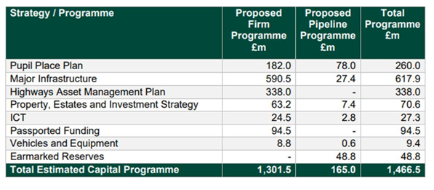
The roll out of the vaccine is welcome news, giving us all hope that we can beat the virus however we must not become complacent as there is still a real threat to us particularly the new variants. There is a reduction in the number of infections, but the numbers are still high compared to the autumn. You can view the latest figures on our new interactive dashboard, which is updated on a daily basis.

We must all play our part in stopping the spread of the virus.

Please continue to follow the Government guidelines.

Please do not hesitate to contact me and keep safe.

Ian Hudspeth
07956 270 318
Ian.hudspeth@oxfordshire.gov.uk

